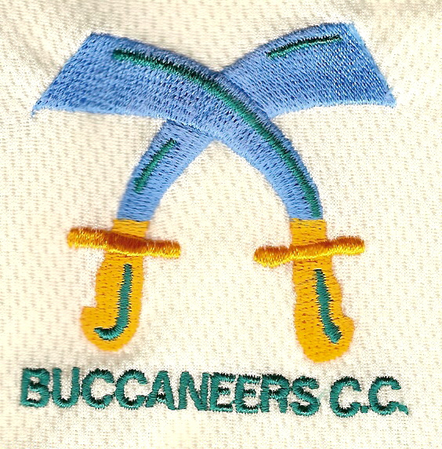

BUCCANEERS CRICKET CLUB

85th ANNUAL DINNER

Thursday 12th March 2015

"Don't miss Matthew Engel and our 'Ale for All' reception at the Buccaneers Annual Dinner on Thursday 12 March at the East India Club.

We're delighted to have persuaded the distinguished writer Matthew Engel, author, Guardian and FT columnist and celebrated editor of Wisden, to speak at our 85th dinner in 16 St James's Square, SW1Y 4LH.

To whet our appetite for Matthew's original thoughts and observations, complimentary cask of ale is provided from 6.30pm. Our AGM starts at 6.30pm and dinner will be served at 8pm. After the delicious 3-course meal, President Simon Woolfries reviews the 2014 season and presents the Geoffrey Moore Trophy to the Player of the Season.

A late bar allows plenty time to socialise after dinner.

We look forward to welcoming you in March.

D.A.Close Esq.

The “small print”: Dress code is strictly lounge suits with ties. Refreshments can be purchased on the night using cash only.

To: D.A.Close Esq., Highfields, New Road, Rotherfield, East Sussex TN6 3JT

I enclose £50 per ticket for the Buccaneers CC Annual Dinner on Thursday 12th March 2015. (Please make cheques payable to “Buccaneers Cricket Club”).

Special dietary requirements: ………………………………………………

I would like to bring the following guest(s):

1 ………………………………………… 2 …………………………………………

Signature: ……………………………………..…………

Name: ……………………………………………………

Address: ……………………………………………………………………………….

Email Address: ………………………………………………………….

